|  |  |  |  |  |
| --- | --- | --- | --- | --- |
| download%20(2) | download |  |  | |
| Date |  |
| Code |  |
| *Person in charge:* | |

**A BK-TERRA AI PROJECT PROPOSAL**

# GENERAL INFORMATION

## A1. PROJECT NAME

**A MULTIVARIATE TIME-SERIES DEEP-LEARNING MODEL FOR AN ONLINE POWERMETRY PROBLEM**

## A2. PROJECT AREAS

Area 1: Embedded Systems, IoTs

Area 2: Deep Learning, Big Data

**Consultancy – an expert of the field**

|  |  |  |  |  |
| --- | --- | --- | --- | --- |
| **#** | **Name** | **Expertise** | **Company / University** | **Contact infor** |
| 1 | Assoc. Prof. Tho Quan (Michael) | Deep Learning, Multidisciplinary Domains | BKU | 0919890203,  qttho@hcmut.edu.vn |

## A3. Research Category

Applied Research, Industrial Research

## A4. Time Constraint

*6+6 months (accomplishment in 6 months, and waiting 6 months for paper to be published).*

## A5. Budget

Total: 57.500.000 VND ~ 2.500 USD

* Budget source: Terralogic Inc. VN
* Other budget source: None
* Details: Included spreadsheet

## A6. Person-in-charge

Terralogic Inc.:

**Thien Pham (Thomas P.)**

Senior Project Manager – Embedded Systems & AI Domains

Emp. ID: 767

Email: [thien.pham@terralogic.com](mailto:thien.pham@terralogic.com) / Tel: 0988 533 468

BKU:

**Assoc. Prof.** Tho Quan

ID: 058073000045; Date-of-issue: 05/06/2019; Place-of-issue: Government office of General People’s Cometee.

Company / University Add: 268 Lý Thường Kiệt, Quận 10, Tp Hồ Chí Minh

Tel/Email: 091 989 0203 ; qttho@hcmut.edu.vn

**Experience summary** *(max 500 words)*

Dr. Quan Thanh Tho, currently Vice Dean of the Faculty of Computer Science and Engineering at Ho Chi Minh City University of Technology (HCMUT) is an Associate Professor in Artificial Intelligence. He got his PhD in Nanyang Technological University (NTU), Singapore in 2006. His areas include Knowledge Representation (ie. Ontology Engineering) and Machine Learning (especially Deep Learning), which are very suitable to this project. He has published over 100 publications, including 12 ISI papers (<http://www.cse.hcmut.edu.vn/qttho/doku.php?id=publications>). Recently, Dr. Tho has published some notable works on using deep learning for knowledge acquisition in various domains (NLP, malware, ECG signal from IoT devices, etc.).

Thien Pham (Thomas P.) is currently serving as a Senior Project Manager in Terralogic Inc. VN. Previously, he served as a Delivery Head of Embedded System Group in Terralogic Vietnam, a Team of 40+ engineers. His main responsibilities were to motivate a dynamic and ambitious Team to move forward and ensure the Embedded Group (40+ employees) revenue over quarters and years. Terralogic Vietnam is a subsidiary of Terralogic Global with 1000+ employees and they have different customers in different working fields. Thomas has been working in hardware and software development, especially in Embedded System, IoT in the Vietnamese IT industry for 18 years. He also has 17 international publications in the related areas (<http://publicationslist.org/congthienvn>).

## A7. Organizations

1. BKU

Rector: Assoc. Prof. Mai Thanh Phong

Tel: (84-28) 38.636.856 Fax: (84-28) 38.636.984

E-mail: khcn@hcmut.edu.vn

1. Terralogic Inc. VN.

General Director, Head of Engineering: Sandeep Metta

Tel: 090 143 35 59

Email: sandeep@terralogic.com

## A8. Other Organizations

*NONE*

## A9. Project Members

|  |  |  |  |  |  |
| --- | --- | --- | --- | --- | --- |
| **#** | **Name** | **Organization** | | **Effort Percentage (%)** | **Role / Comment** |
|  | | | **Main resources** | | |
| 1 | Prof. Tho Quan | BKU | | 10 | Consultant |
| 2 | Thomas P. | Terralogic Inc. | | 30 | Project Manager / Project Owner / Trainer |
| 3 | Engineer 1 | Terralogic Inc. | | 100 | Fresher, Trainee |
| 4 | Engineer 2 | Terralogic Inc. | | 50 | Fresher, Trainee |
| 5 | Engineer 3 | Terralogic Inc. | | 50 | Fresher, Trainee |
|  | | | **Additional resources** | | |
| 6 | Nguyen Tam Dat | BKU Student | | 50 | 4th-year |
| 7 | Bui Tuan Anh | HCMUTE Student | | 50 | 3rd-year |
| 8 | Dao Nhat Tam | HCMUTE Student | | 50 | 4th-year |
| 9 | Dinh Quoc Thuy | HCMUTE Student | | 50 | 3rd-year |
| 10 | Le Phuong Nam | HCMUTE Student | | 50 | 3rd- year |

# PROJECT INFORMATION

## 

# B1.INTRODUCTION

### AI, MACHINE LEARNING AND DEEP LEARNING

Artificial Intelligence is a traditional subject in computer science. Studies of the field have been envolved and directed to a narrow topic over the years. Recently, since 2000, the research topic creates giant interest from the communities including academic and enterprises fellows.  Along with today development, together with enhancement in hardware industry, the area of AI, Machine Learning (ML) and Deep Learning (DL) have changed significantly [1].

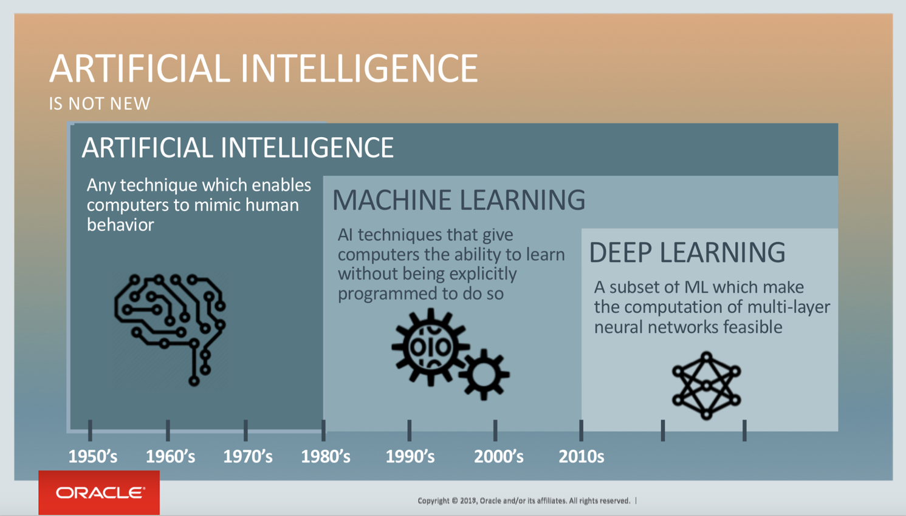

Figure 1. The AI, ML and DL envolvement over the time [1]

The general public have been actively adapted to the above changes. A great number of traditional applications with moderate results have been investigated to apply AI-related techniques and archive better performance, sometimes dramatic differences. A lot of devices and operation utilizing the productiveness of AI have been delivered. Computer Engineers also quickly trained by AI competence to follow the trends and join the new related projects. According to Garner [2], DL belongs to the top 5 hot development topics during the recent five years (2018-2022). It is even said that the AI’s impact is everywhere [3] to emphasize the crucial influence.

Figure 1. described the development of AI, ML and DL during the recent years. Following the timeline, DL researches have been evolved majorly since 2010s, when the hardware technologies archived enormously to a triggered boundary. In this proposal, we aim to apply DL technologies into a traditional problem that was raised for a long time in the history, the battery capacity management problem (Powermetry). Similar to many other existing topics, the performance of the problems solutions is limited. Therefore, we expect that our AI-enabled method can help to outweigh the challenge with better performance and gain a major part of industrial knowledge experience.

### The battery capacity management problem

Lithium Ion Battery (LIB) is a type of rechargeable battery commonly manufactured in the market. During the charging process, the positive ions (Li+) move from cathode to anode and vice versa in the discharging process (using time) to create the current. LIB is mostly used for mobile devices, especially lightweight wearables. However, it has sometimes been used for big moving objects such as cars, drones, unmanned aerial vehicles, etc.

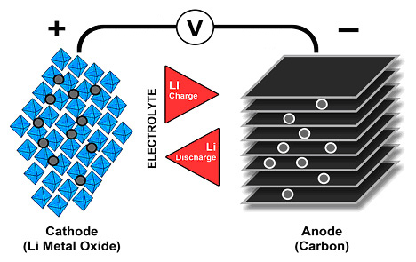

Figure 2. Ion flow in lithium-ion battery

During the recent 2 decades, the power systems using LIBs have got high attention from the community and have been used in a lot of devices in the market [4]. Those outdoor moving objects, mobile devices, solar power devices … are required to use LIBs due to their features like lightweight, durability, high capacity, self discharge ability. Therefore, some additional features such as safety, durability without issues, number of working cycles, … are highly demanding. Moreover, the requirement includes optimizing design to deliver a LIB with stable and durable working time. Recently, the main interests consist of overcharging, self-discharging, capacity fading, impedance, shocks, aging … [5].

To solve these kind of problems, people usually design a hardware system called battery management system (Figure 3). This system is sometime called a battery pack; helps to measure many crucial data from different LIB modules concurrently. Among those data, the State of Charge (SOC) and State of Health (SOH) are the most considerable. The reasons should be almost all the real time / online applications have direct or indirect involvement to SOC/SOH. Therefore, a real time system helps to monitor these data items will create meaningful support for battery risks and failure detection and prevention; increasing reliability greatly for the target system.

Recently, LIB research topics are classified into these two kinds: **electrochemical** and **equivalent circuit model**. The electrochemical class use finite element analysis or derivative equations and usually have problem of computation complexity [6]. On the other hand, the equivalent circuit models are parameterised, alternated and can be used during a long time. Besides, the 2000-2012 era have recorded many researches lead acid battery to the advanced finite element of LIBs [7]. The finite element softwares uses physical models to analyze the deep understanding of physical-chemistry of cell level of LIBs have also been found. Those of intelligent methods, Neural Network, genetic algorithm … have been used to solve the capacity estimation for LIBs. In the later sections, we will discuss these methods with more details.

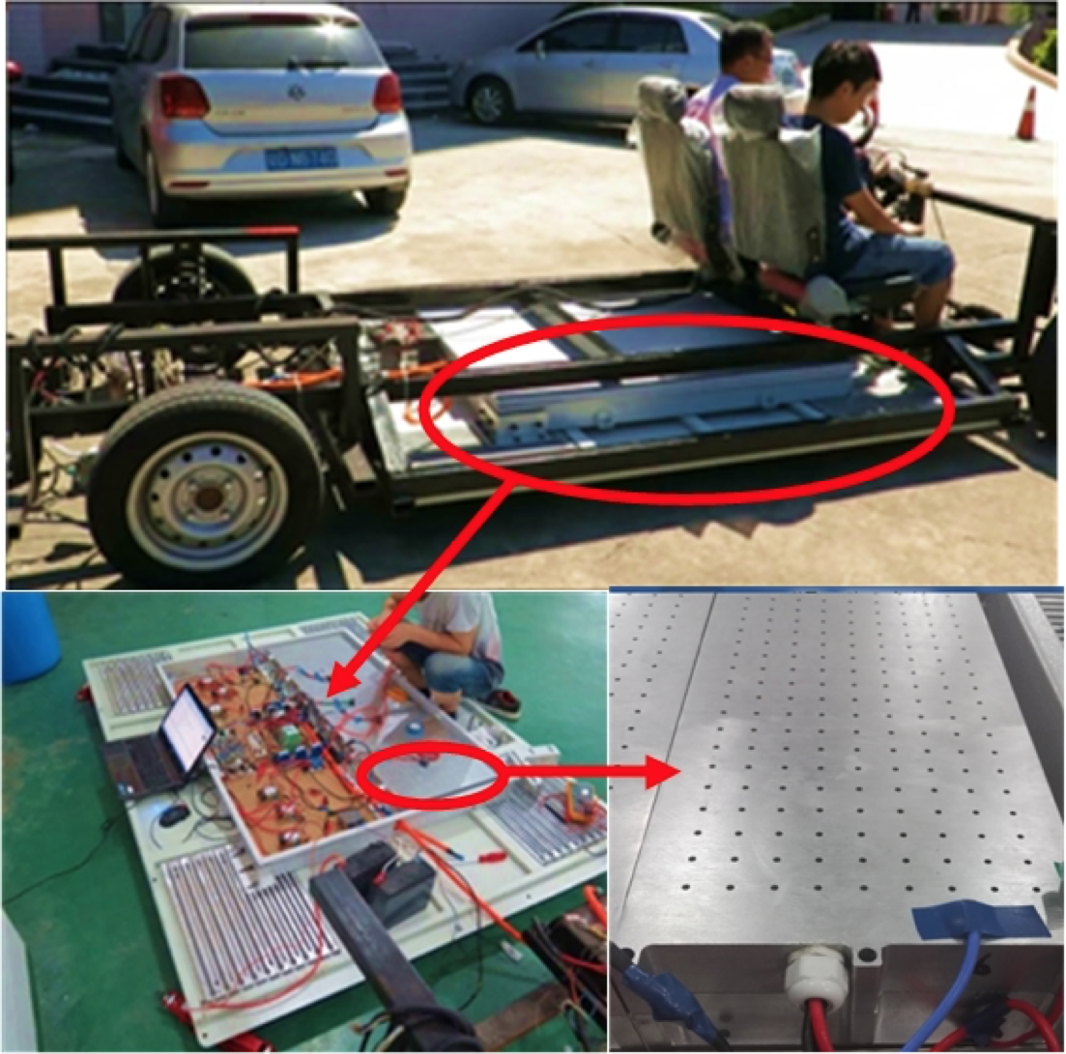 Figure 3. A battery management system. The top part is the system on a moving device. The bottom parts are the hardware devices inside it.

### The multivariate online problems

In practice, the online time-series multivariate problems are very common and highly demanding. For instance, the prediction of the stock market, the voice recognition, the handwriting recognition or the capacity estimation like our problems are obviously good examples. With respect to multivariate time-series topic, it can be foreseen that a future datum will change accordingly to the past and present parameters. Sometimes, these problems have been mentioned as stochastic processes because they reflect the variance by stochastic realtime vector.

Multivariate is the attribute of multi-changing inputs and outputs parallely. In our SOC/SOH estimation computation, the inputs can be listed as current, voltage, charging capacity, temperature... Correspondingly, the outputs are discharge capacity, new temperature, or derivative over time (dV/dt). In some other industrial examples, such as step detection, working modes optimization (based on mobile user experience), the multivariate level should have been raised up to another higher amount. Therefore, the model that we proposed should be able to solve these general common problems.

### AI Technologies into LIBs Problem

There are some recent researches on the field and they can be classified as (1) traditional model-based methods considering empirical models and (2) kernel regression approaches and Neural Network [8]. In more details, the model-based methods go with hardware, measurement tools, online data collection and the computation models are Kalman Filter (EKF), Taylor series, sigma-point Kalman Filter (SPKF), particle filter.

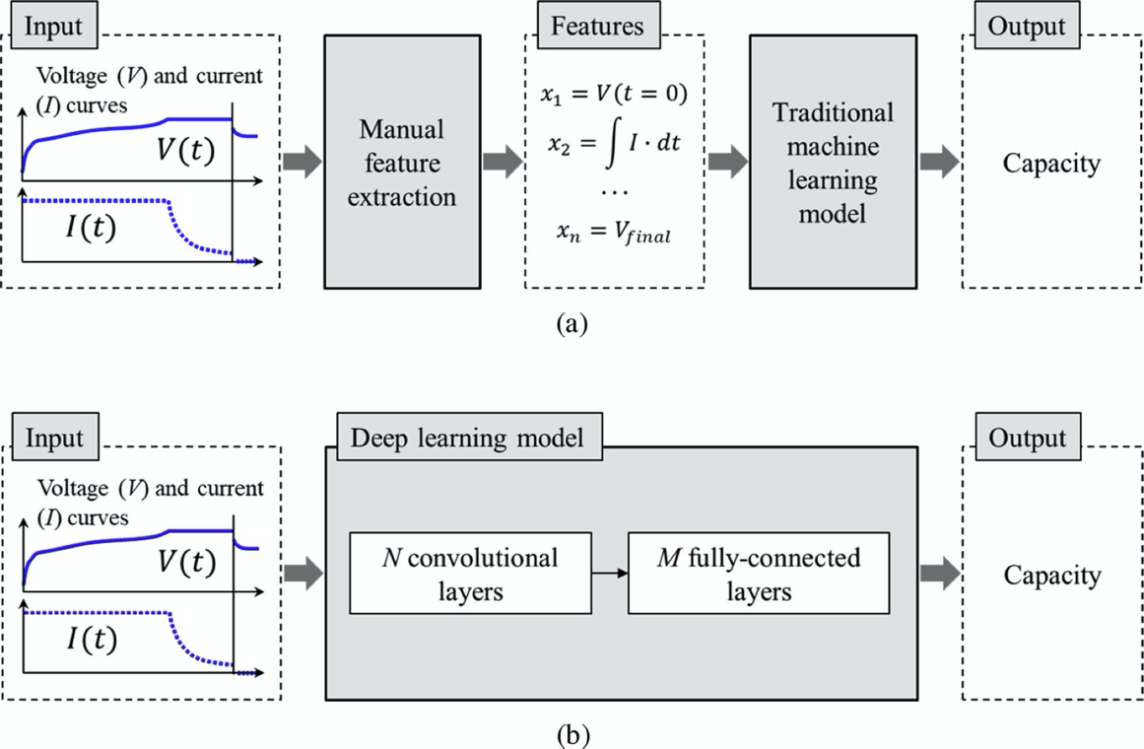

Figure 4. The key difference between traditional approaches (a) and kernel regression approaches and Neural Network (b) [8].

Although there are many studies, the main obstacle is the accuracy of measurement devices, and the cost to be spent in controlling different options. Besides, the system also asked for deep knowledge of physical and mechanical competence. Therefore, models based on AI-DL have more attention recently because:

* The deep knowledge of LIB hardware related is not required
* Sensors, high bandwidth, big data technologies enable the data collection efficiently; creating good inputs for the models. Some of big-data sources are Nasa [9], Oxford [10], Center for Advanced Life Cycle Engineering (CALCE) [11] or Sandia National Labs [12] and 124-cells of [13].
* In these methods, the [8] had proposed a method with high quality result. However, the shortcoming of the methods include the contribution of full capability to analyze dependency of large volume of data and poorly extract characteristic features). Figure 4 explains these comparisons and the approach that AI-DL methods help to solve the issue. We will introduce the approach and create the solution proposal in the following sections.

# B2.LITERATURE REVIEWS

### GLOBAL LITERATURE REVIEWS

LIBs Studies

LIBs - Pin lithium-ion have high energy integration, lightweight and durable which are applicable for many different [27]. Current studies are trying to improve LIBs efficiency. The capacity is one of the most considerable indexes, and is influenced by internal and external working situation (environment, age, using behaviour, charging inputs …) [28-29]. Therefore, the LIBs capacity should be correctly estimated and the efficient usage are to be considered [30]. Figure 5 described a cycle of charge / discharge of a Lithium-ion cell [31]. The vertical axis shows the change of voltage over time (the horizontal axis), starting from fully charged till the end-of-discharge voltage (EODV) level. The current is kept unchanged during this process and the time is limited to this full cycle for discharging. The battery capacity is calculated as the area under the discharge curve, measured by Ampere hour (Ah).

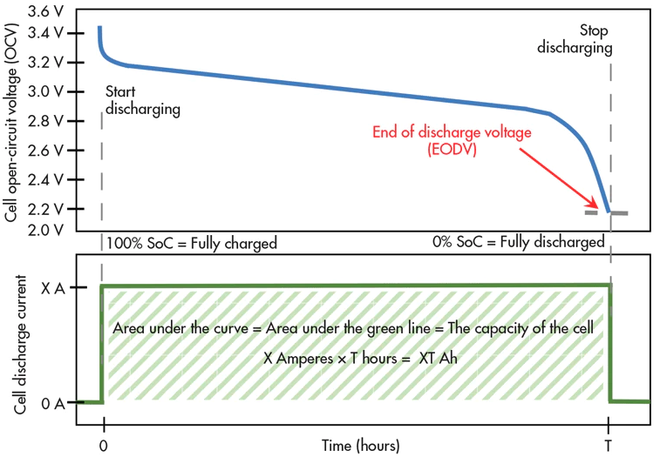

Figure 5. A cycle of charge / discharge of a Lithium-ion cell.

It can be seen that the battery capacity estimation is crucial in practical problems. Current studies approach the methods by electrochemical [31] and equivalent circuit model [32] and analytics models [33]. These methods are based on the physical-chemistry process of LIBs and the efficiency based on a long time using [34-36]. Some methods use Open Circuit-Voltage (OCV), to calculate the cycle of computation have also been published [38 - 39]. Overall, these methods are time-consuming and low-accurate regardless of the high accuracy of measurement devices. By these kinds of methodologies, numbers of experiments are giant, take a lot of time and require very much concentration and effort.

Recently, [40] uses a low-accurate database but creates online high-quality results based on the similarity of the data curves; which is considered as an efficient method of using data. However, the study required a giant time of data collection to define the sample curves and it limited the practical applications. Another research [41] approached the visual cognition to define the data analysis model. These existing studies create low-accuracy data and have not utilized the efficiency of big-data deep learning.

AI-DL approaches

AI is a classical topic in computer science. In history, AI studies continuously developed their computational achievements in the past. However, till the recent 2010s, AI-related applications have been creating a breakthrough and obtain great consideration from the community. It is said that the hardware performance and capacity have empowered the evolvement of ML and DL – narrow topics from AI – and generate great applications nowadays.

Regarding recent above DL and capacity estimation approaches, we will get through some of the examples. The electrochemical researches using a measurement method to calculate online data of LIBs using extended Kalman Filter (EKF) [14] used a practical discrete space; the SOC is considered as output and the capacity / resistance are inputs. EKF are not stable occasionally to these nonlinear problems due to Taylor series to linearize and reduce the main features of data [15]. To solve the above shortcoming of EKF, some studies create an alternative model called sigma-point Kalam filter (SPKF). The base idea is the usage of sigma-points series which is undefined weighted sample points (minimal set of deterministically-chosen, weighted sample points). SPKF approximate the distributions by optimizing and manually adjusting the dimension of data [16]. The bi-SPKF enabled the estimation of SOC, capacity and resistance simultaneously. The works of [14] and [16] had inspired the development of many same category approaches such as EKF [17, 18], SPKF [19], H-infinite filter [20] and particle filter [21] for LIBs SOC and capacity estimation. However, the accuracy of the methods (using practical measurement) rely heavily on the applicability of the assessment, i.e the compatibility of the model and the reality, which is the most challenging part in real applications model design.

A different approach to replace the above methods is using a physics-based electrochemical model. The study [22] developed an adaptive observer algorithm to calculate data of battery efficiency using voltage and current. Another research [23] estimated capacity fading by Bayesian reduced-order algorithms EKF, Kalman and Particle Filter. There are some approaches to help solving the shortcoming of these above methods such as relevance vector machine (RVM) [24] and k-nearest regression KNN [25]. The study [26] selected five feature data manually to represent cell capacity then used RVM to estimate the mapping to capacity attributes.

The mentioned traditional DL methods created quite accurate results. Still, limitation and still be seen based on the following observation. Firstly, the big source of data had not been utilized fully. Secondly, the feature extraction manually relied on people and the LIBs understanding. It should be very challenging to define the features carrying correct information of the specific problems, i.e capacity information in our case. Finally, the extraction are different because of the application variety [27].

### VIETNAMESES LITERATURE REVIEW

In Vietnam, there are not many researches about LIBs; most of the existing studies work on the user perspective and do not go deep into physical-chemistry battery features. Some of the obvious reasons are the techniques have not been studied domestically. We will list some of the publications among them.

The document [42] recorded standard for LIB manufacture nationally. All hand-held devices using batteries need to follow details of charging, discharging, resistance and safety condition over time. The document noticed the mandatory requirements to all batteries and devices using batteries inside the country. Technically, some of the details were missing especially for measurement of physical-chemistry LIBs features. To automate the assessment, there is a PCB hardware [43] helps to archive capacity and basic information (current, voltage) simultaneously. The board is mainly used for evaluation and simple (low accurate) analysis, which is not relevant for high performance and real time survey. Another study [44] provided data of LIBs using represented cycles in Honda Lead 110cc scooter. The author recommended a Lion 48V-33Ah power supply and simulate the system on Matlab/Simulink. The [44] also advised that additional experiment on real vehicles should be given.

Therefore, compared to many existing studies globally, the Vietnamese domestic researches are very few on both quality and quantity; as mentioned.

Based on the above evaluation, the studies of AI-DL on LIBs information have been highly considered from us by either academic and industrial perspective. Moreover, we will inherit the foundation of data-driven and big-data on deep learning of the existing research, aiming to create difference and more powerful results. Our input could be some of these sources:

* Data collected online from NASA [9], Oxford [10], (CALCE) [11] or Sandia National Labs [12] and 124-cells of [13]
* Data from our existing **smart-watch project in Terralogic**
* Data from [4] (4 months LIBs) – Figure 6



Figure 6. A plot shows a full cycle of LIB charging [4].

We process the big data and train the model based on these sources. Later on, we estimate multivariate output of capacity, temperature, fading capacity … from them. Data of outputs will be analyzed to optimize the model and verify our methods, comparing with the existing studies.

The later sections of this proposal include as follows. The list of acronyms and LIBs parameters are given in section B3.1 and B3.2. The reference lists is described in B4. The B5 provides details of project plan and expected deliverables in the 12-months. Finally, the B6 secssion and a spreadsheet document attached share the budget estimation for this proposal.

## B3.1 ACRONYMS

|  |  |  |
| --- | --- | --- |
| **#** | **ACRONYMS** | **MEANING** |
| 1 | SOH | State of Health |
| 2 | SOC | State of Charge |
| 3 | NN | Neural Network |
| 4 | LIB | Lithium-Ion Battery |
| 5 | EKF | Extended Kalman Filter |
| 6 | EODV | End of Discharge Voltage |
| 7 | DOD | Depth of Discharge |
| 8 | OCV | Open Circuit Voltage |
| 9 | dV/dT | Derivative of Voltage over Time |
| 10 | AI | Artificial Intelligent |
| 11 | ML | Machine Learning |
| 12 | DL | Deep Learning |
| 13 | RVM | Relevance Vector Machine |
| 14 | KNN | K-nearest Regression Neural Networks |
| 15 | CNN | Convolutional Neural Network |
| 16 | RNN | Recurrent Neural Network |
| 17 | LSTM | Long Short Term Memory |

**B3.2 LIBs parameters**

|  |  |  |
| --- | --- | --- |
| **Index** | **Parameters** | **Comment** |
| 1 | Date_time | Date/Time of the measurement |
| 2 | Step_Time | Step |
| 3 | Step_Index |  |
| 4 | Cycle_Index |  |
| 5 | Voltage | Charging Voltage |
| 6 | Current | Charging Current |
| 7 | Charge_Capacity |  |
| 8 | Discharge_Capacity |  |
| 9 | Internal_Resistance |  |
| 10 | Dv/dt | Derivative over time |
| 11 | Aux_Temparature | Temperature that the sensor can measure |

## B4. REFERENCE

1. P. Jeffcock. What's the Difference Between AI, Machine Learning, and Deep Learning? Oracle Big Data blog, available at: <https://blogs.oracle.com/bigdata/difference-ai-machine-learning-deep-learning>, 2018.
2. M. Walker. Garner Hype Cycle for Emerging Technologies, available at: https://www.gartner.com/en/documents/3885468/hype-cycle-for-emerging-technologies-2018, 2018.
3. M. Thomas. The future of Artificial Intelligence, available at: https://builtin.com/artificial-intelligence/artificial-intelligence-future, 2019.
4. X. Liang et. al. Evaluation of battery modules state for electric vehicle using artificial neural network and experimental validation, Energy Sci Engineering, 2018
5. W. Waag W et. al. Critical review of the methods for monitoring of lithium-ion batteries in electric and hybrid ve- hicles. J Power Sources. 2014; 258:321–339, 2014.
6. H Al-Sheikh et. al. A sensor fault diagnosis scheme for a DC/DC converter used in hybrid electric vehicles. IFAC-PapersOnLine. 713–719, 2015.
7. L Ungurean et. al. Battery state of health estimation: a structured review of models, methods and commercial devices. Int J Energy Res. 2017;41(2):151–181.
8. S. Sheng et. al. A deep learning method for online capacity estimation of lithium-ion batteries, Journal of Energy Storage, 100817, 2019.
9. B. Bole, Chetan S. Kulkarni, Matthew Daigle, Adaptation of an Electrochemistry- based Li-ion Battery Model to Account for Deterioration Observed Under Randomized Use, SGT, Inc. Moffett Field United States, 2014.
10. R. R. Richardson, Christoph R. Birkl, Michael A. Osborne, David A. Howey, Gaussian process regression for in situ capacity estimation of lithium-ion batteries, IEEE Trans. Ind. Inform. 15 (1) (2018) 127–138.
11. CALCE Battery Research Group. (2017). Retrieved June 18, 2019, from https:// web.calce.umd.edu/batteries/data.htm.
12. H. M. Barkholtz, Armando Fresquez, Babu R. Chalamala, Summer R. Ferreira, A database for comparative electrochemical performance of commercial 18650- format lithium-ion cells, J. Electrochem. Soc. 164 (12) (2017) A2697–A2706.
13. K. A. Severson, Peter M. Attia, Norman Jin, Nicholas Perkins, Benben Jiang, Zi Yang, Michael H. Chen, et al., Data-driven prediction of battery cycle life before capacity degradation, Nat. Energy (2019).
14. G. L. Plett. Extended Kalman filtering for battery managements ystems of LiPB-based HEV battery packs: part 3. state and parameter estimation, J. Power Sources 134 (2) 2004.
15. R. V. D. Merwe, Eric Wan, Simon Julier, Sigma-point Kalman filters for nonlinear estimation and sensor-fusion: applications to integrated navigation, AIAA Guidance, Navigation, and Control Conference and Exhibit, p. 5120, 2004.
16. G. L. Plett, Sigma-point Kalman filtering for battery management systems of LiPB-based HEV battery packs: part 2: simultaneous state and parameter estimation, J. Power Sources 161 (2), 2006.
17. C. Hu et. al. A multi scale framework with extended Kalman filter for Lithium-ion battery SOC and capacity estimation, Appl. Energy 92 (2012) 694–704.
18. Y. Zou et. al. Combined state of charge and state of health estimation over lithium-ion battery cell cycle lifespan for electric vehicles, J. Power Sources 273, 2015.
19. F. Zhang, Guangjun Liu, Lijin Fang, Battery state estimation using unscented Kalman filter, IEEE International Conference on Robotics and Automation, ICRA’09, 2009.
20. C. Chen et. al. A lithium-ion battery-in-the-loop approach to test and validate multiscale dual h infinity filters for state-of-charge and capacity estimation, IEEE Trans. Power Electron. 33 (1), 2018.
21. E. Benjamín et. al. Particle-filtering-based prognosis framework for energy storage devices with a statistical characterization of state-of-health regeneration phenomena, IEEE Trans. Instrum. Meas. 62 (2) 2013.
22. S. J. Moura et. al. Adaptive partial differential equation observer for battery state-of-charge/state-of-health estimation via an electrochemical model, J. Dyn. Syst. Meas. Control 136 (1) (2014) 011015.
23. A. Bartlett et. al, Electrochemical model-based state of charge and capacity estimation for a composite electrode lithium-ion battery, IEEE Trans. Control. Syst. Technol. 24 (2) (2016) 384–399.
24. Chao Hu, Gaurav Jain, Craig Schmidt, Carrie Strief, Melani Sullivan, Online estimation of lithium-ion battery capacity using sparse Bayesian learning, J. Power Sources 289 (2015) 105–113.
25. Amir Navot, Lavi Shpigelman, Naftali Tishby, Eilon Vaadia, Nearest neighbor based feature selection for regression and its application to neural activity, Advances in Neural Information Processing Systems, (2006), pp. 996–1002.
26. Chao Hu, Gaurav Jain, Puqiang Zhang, Craig Schmidt, Parthasarathy Gomadam, Tom Gorka, Data-driven method based on particle swarm optimization and k- nearest neighbor regression for estimating capacity of lithium-ion battery, Appl. Energy 129 (2014) 49–55.
27. C. Y. Lin. A review of AI Technologies for Wearable Devices, IOP Conference Series: Materials Science and Engineering, 2019.
28. L. Chen, W. Lin, J. Li, B. Tian, and H. Pan, “Prediction of lithium-ion battery capacity with metabolic grey model,” Energy, vol. 106, pp. 662–672, 2016.
29. G. Dong, X. Zhang, C. Zhang, and Z. Chen, “A method for state of energy estimation of lithium-ion batteries based on neural network model,” Energy, vol. 90, pp. 879–888, 2015.
30. B. Xia, C. Chen, Y. Tian, M. Wang, W. Sun, and Z. Xu, “State of charge estimation of lithium-ion batteries based on an improved parameter identification method,” Energy, vol. 90, pp. 1426–1434, 2015.
31. Z. Deng, L. Yang, Y. Cai, H. Deng, and L. Sun, “Online available capacity prediction and state of charge estimation based on advanced data-driven algorithms for lithium iron phosphate battery,” Energy, vol. 112, pp. 469–480, 2016.
32. B. Zollo. Measuring Cell Capacity, Electronic Design, available at: https://www.electronicdesign.com/technologies/test-measurement/article/21805209/measuring-cell-capacity, 2017.
33. B. Y. Liaw, R. G. Jungst, G. Nagasubramanian, H. L. Case, and D. H. Doughty, “Modeling capacity fade in lithium-ion cells,” Journal of Power Sources, vol. 140, no. 1, pp. 157–161, 2005.
34. C. Hu, B. D. Youn, and J. Chung, “A multiscale framework with extended Kalman filter for lithium-ion battery SOC and capacity estimation,” Applied Energy, vol. 92, pp. 694–704, 2012.
35. R. Xiong, F. Sun, Z. Chen, and H. He, “A data-driven multi-scale extended Kalman filtering based parameter and state estimation approach of lithium-ion polymer battery in electric vehicles,” Applied Energy, vol. 113, pp. 463–476, 2014.
36. A. Singh, A. Izadian, and S. Anwar, “Model based condition monitoring in lithium-ion batteries,” Journal of Power Sources, vol. 268, pp. 459–468, 2014.
37. J. Yi, J. Lee, C. B. Shin, T. Han, and S. Park, “Modeling of the transient behaviors of a lithium-ion battery during dynamic cycling,” Journal of Power Sources, vol. 277, pp. 379–386, 2015.
38. M. Einhorn, F. V. Conte, C. Kral, and J. Fleig, “A method for online capacity estimation of lithium ion battery cells using the state of charge and the transferred charge,” IEEE Transactions on Industry Applications, vol. 48, no. 2, pp. 736–741, 2012.
39. J. Zhang and J. Lee, “A review on prognostics and health monitoring of Li-ion battery,” Journal of Power Sources, vol. 196, no. 15, pp. 6007–6014, 2011.
40. L. Tao, C. Lu, and A. Noktehdan, “Similarity recognition of online data curves based on dynamic spatial time warping for the estimation of lithium-ion battery capacity,” Journal of Power Sources, vol. 293, pp. 751–759, 2015.
41. Y. Cheng et. al. Lithium-Ion Battery Capacity Estimation: A Method Based on Visual Cognition. Fault Identification, Diagnosis, and Prognostics Based on Complex Signal Analysis, 2017.
42. Bộ TTTT. Quy chuẩn kỹ thuật quốc gia về pin Lithium cho thiết bị cầm tay. QCVN 101:2016/BTTTT, 2016.
43. Mạch kiểm tra dung lượng pin Lithium 18650; available at: https://thegioiic.com/products/mach-kiem-tra-dung-luong-pin-18650, 2019.
44. N. V. Trạng et. al. Nghiên cứu tối ưu tính năng làm việc của pin Lithium-ion sử dụng cho xe gắn máy tích hợp truyền động lai. Tạp chí Phát triển Khoa học và Công nghệ, tập 20, số K6-2017.
45. C. Ruhatiyaa, Pham Ngo Gia Bao, Tram Loi Quan, Quan Thanh Tho, Li Xinyu, “A Hybrid Multi-Output-Predictive Modelling based NSGA II Approach for Dimensions Design Optimization of Battery Pack Module for Electric Vehicles”, Energy Storage, 2020.
46. C.P. Patrick Reid. Handbook for preparing and writing research proposals. University of Anizona, International Union of Forestry Research Organization (IUFRO), Vienna, Austria, 164p, 2000.

## B5. PROJECT PLAN

### B5.1 PROJECT PROBLEM

The problem belongs to powermetry obstacle. We aim to study on the Lithium-Ion Batteries and related parameters that impact the battery efficiency over time. Later on, we use an AI-DL model to work on the big-data collected and propose a multivariate online time-series solutions to estimate different output parameters parallely. The solutions is generated so that we can enhance for future various industrial similar problems such as step detection, power optimization.

### B5.2 OUTPUT DETAILS

1. Running Demo

The Demo will be built based on the understanding of LIBs and AI-DL is delivered by the end of the first 6-month of the project. Some of the information is:

* Programing language: Python or Matlab / Octave
* Frameworks: TensorFlow, Keras, Pandas
* Source code Revision Control space: Colab

The Demo should be able to perform well on existing training data and create output comparable to existing publications. The Demo is cross platform and all the project members are able to execute, contribute and verify there current progress parallely.

The model is extendable for future projects of similar problems.

1. Publish Paper

|  |  |  |  |
| --- | --- | --- | --- |
| **Index** | **Publication** | **Quantity** | **Expected Publisher** |
| 1 | International Blind-reviewed Conference Paper | 1 | Wiley Online Library – Energy Science & Engineering 2020. |

1. Resource Training

The project aim to create AI-DL competence for Terralogic engineers, including:

* Project management (1 PM with 30-40% effort)
* Freshers (1 engineer full load - 100% effort, 3-6 engineers half load – 50%) involved into the project and have hand-on experience
* Internship (3-6 students from BKU or HCMUT join to project so that they can learn the practical and modern technologies on the fields, effort required 50%)

End of the project, participants gain competence of AI-DL with the frameworks, libraries, hyperparameters that will impact the results, evaluation tools, and future techniques.

1. BK-Terra Partnership

This project is part of the collaboration from both parties (BKU and Terralogic) to enhance our relationship as the BKU helps to apply state-of-the-art DL technologies into an industrial POC project in Terralogic. The project also helps to create co-publication(s) and build employees’ competence. Additional activities should be (and is not limited to) continuous human resource co-training, recruitment, research and applied technologies in various domains.

### B5.3 Project Plan

### 

|  |  |  |  |  |  |  |  |  |  |  |  |  |
| --- | --- | --- | --- | --- | --- | --- | --- | --- | --- | --- | --- | --- |
|  | **Month 1-6** | | | | | | **Month 7-12** | | | | | |
|  | Mon  #01 | Mon  #02 | Mon  #03 | Mon  #04 | Mon  #05 | Mon  #06 | Mon  #07 | Mon  #08 | Mon  #09 | Mon  #10 | Mon  #11 | Mon  #12 |
| Study / Investigation |  |  |  |  |  |  |  |  |  |  |  |  |
| Pilot Project |  |  |  |  |  |  |  |  |  |  |  |  |
| Collecting experiment (lost < 3%) |  |  |  |  |  |  |  |  |  |  |  |  |
| Collecting experiment (lost <1%) |  |  |  |  |  |  |  |  |  |  |  |  |
| Demos & writing paper |  |  |  |  |  |  |  |  |  |  |  |  |
| Submit paper |  |  |  |  |  |  |  |  |  |  |  |  |
| Enhance the result & training |  |  |  |  |  |  |  |  |  |  |  |  |
| Paper published |  |  |  |  |  |  |  |  |  |  |  |  |

## 

## B6. BUDGET ESTIMATION

Attached spreadsheet (to be continued and will be provided).

|  |  |
| --- | --- |
| *Day ...... month ...... year....* | *Day ...... month ...... year....* |
| **Bach Khoa University**  *Assc. Prof. Quan Thanh Tho* | **Terralogic Inc. Vietnam** |